Segments
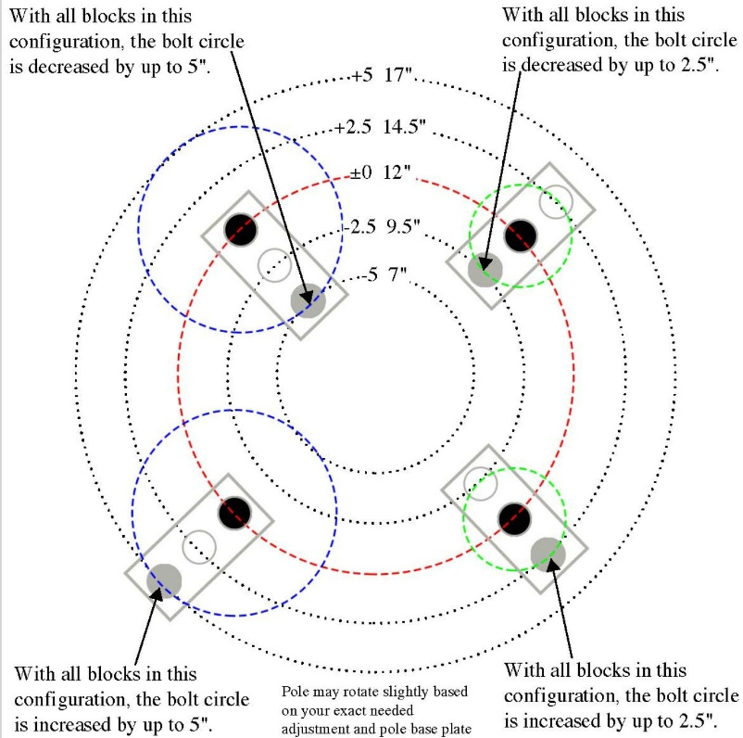
- Anchor Bolts segment
input
- N_{b} = total number of anchor bolts
- db = nominal anchor bolt diameter (in)
- dh = anchor bolt hole diameter (in)
- rb = anchor bolt circle radius (ft or in)
- αb = start angle of first anchor bolt (deg)
- θ_{seg} = segment angle (deg), if bolts are checked by segment
- n_{s} = number of segments
- t_{bp} = base plate thickness (in)
- f_{y} = bolt yield strength, if needed
- f_{u} = bolt ultimate strength, if needed
- T_{u} = design uplift/tension demand on one bolt or bolt group
- V_{u} = design shear demand on one bolt or bolt group
- φ = resistance factor, if your software includes strength check
- e = edge distance from hole to plate edge, if required
- s = bolt spacing, if user enters directly
- nbs = number of bolts per segment

output
- Bolt cross-sectional area
If we consider nominal diameter
$$A_{b}= \frac{πd_{b}^{2}}{4} \left({inch}^{2}\right)$$
2) Hole area
$$A_{h}= \frac{πd_{h}^{2}}{4}$$
3) Bolt angular spacing around full circle
$${Δθ}_{b}= \frac{360}{N_{b}}$$
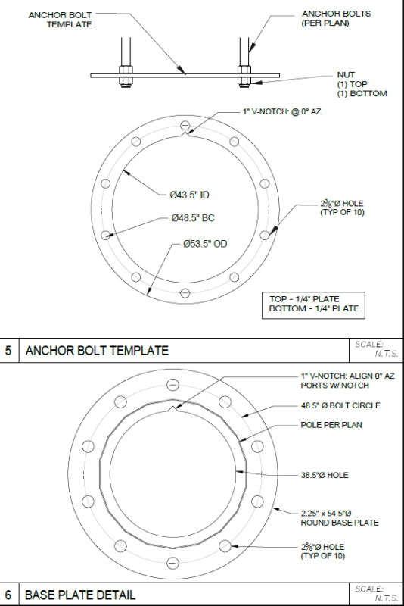
4) Angle of each bolt
For bolt $i$:
$$θ_{i}= α_{b}+\left(i-1\right)∆θ_{b}$$
5) Coordinates of each anchor bolt
If on bolt circle radius $r_{b}$:
$$x_{i}= r_{b}cosθ_{i}$$
$$y_{i}= r_{b}sinθ_{i}$$

6) Arc spacing between adjacent bolts
$$S_{arc}=r_{b}∆θ_{b} \frac{π}{180}$$
7) Chord spacing between adjacent bolts
This is usually more practical than arc spacing:
$$S_{chord}={2r}_{b}\sin{\frac{∆θ_{b}}{2}}$$
8) Number of bolts per segment

$$n_{bs}= \frac{N_{b}}{n_{s}}$$
This should be an integer.
If not, the software should flag a warning.

9) Bolt hole clear edge distance check
If the hole is located between plate edges, the minimum clear edge distance can be written as:
$$e_{clear}=e- \frac{d_{h}}{2}$$
10) Tension demand per bolt
If total uplift is shared equally:
$$T_{bolt}= \frac{T_{u}}{N_{b}}$$
$$T_{bolt}= \frac{T_{u}}{N_{effi}}$$

If only some bolts resist uplift we are using the last equation where $N_{effi}=effictive number of bolts in tension$.

11) Shear demand per bolt
If total shear is shared equally:
$$V_{bolt}= \frac{V_{u}}{N_{b}}$$

12) Tensile capacity of one bolt Basic form:
$$P_{nt}=A_{b}F_{nt}$$
or design strength:
$$∅P_{nt}={∅A}_{b}F_{nt}$$
If we use ultimate strength:
$$∅P_{nt}={∅A}_{b}F_{u}$$
13) Shear capacity of one bolt
$$V_{n}=A_{b}F_{nv}$$
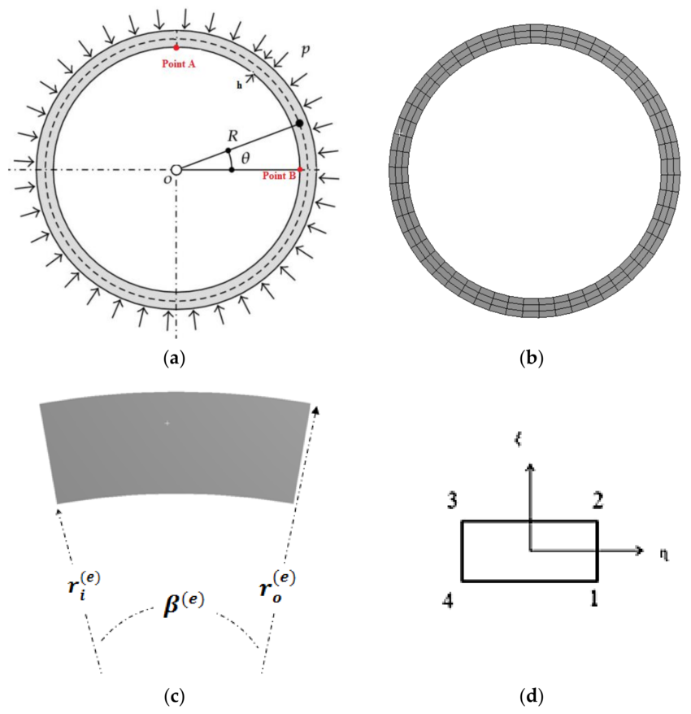
or design strength:
$${∅V}_{n}={∅A}_{b}F_{nv}$$
14) Interaction check for combined tension and shear
A simple software form can be:
$Utilization= \frac{T_{bolt}}{∅P_{nt}}$ + $\frac{V_{bolt}}{{∅V}_{n}}$
Pass if:
$$Utilization≤1.0$$
- Base plate segment
input
- Dbp = base plate diameter (ft or in)
- Ro = base plate outside radius
- Ri = base plate inside radius
- θ = base plate segment angle (deg)
- t = base plate thickness (in)
- n = number of base plate segments
- rs = steel unit weight = 490 pcf
- Nh = number of anchor bolt holes in one segment
- dh = diameter of anchor bolt hole
- α = start angle of segment (deg), if you want location in plan
- rb = bolt circle radius, if bolt layout is needed
Output
- Gross area, $A_{g}$
$$A_{g}= \frac{θ}{360}π \left(R_{0}^{2}- R_{i}^{2}\right)$$
- Net area, $A_{n}$
$$A_{n}=A_{g}- N_{h}\left( \frac{πd_{h}^{2}}{4} \right)\frac{1}{144}$$

- Volume, $V$
$$V= A_{g}\left(\frac{t}{12}\right)$$

- Weight per segment, $W_{bp}$
$$W_{bp}= A_{g}( \frac{t}{12}) ( \frac{r_{s}}{1000}$$
- Total weight, $W_{bp,total}$
$$W_{bp,total}=n .W_{bp}$$
- Outer arc length, $L_{o}$
$$L_{o} =R_{0} .θ_{r}$$
- Inner arc length, $L_{i}$
$$L_{i} =R_{i} .θ_{r}$$
$$θ_{r}= θ\left(\frac{π}{180}\right)$$
- Radial width, $b$
$$b =R_{0}-R_{i}$$
- Centroid radius, $\overset{ˉ}{r}$
For one segment, the centroid lies on the segment centerline:
$$\overset{ˉ}{r} = \frac{4\sin\left(\frac{θr​}{2}\right)}{{3θ}_{s}} x \frac{R_{0}^{3}- R_{i}^{3}}{R_{0}^{2}- R_{i}^{2}}$$
$\overset{ˉ}{r}$= radial location of centroid from center
$θ_{s}$= segment angle (in radians)

- Centroid angle of segment
$$β= ∝ + \frac{θ}{2}$$
$β$= centroid angle (location of centroid in angular direction)
$α$= starting angle of the segment
$θ$= segment angle
Centroid coordinates, $\left(x_{c} , y_{c}\right)$

$$x_{c}= \overset{ˉ}{r}cosβ$$
$$y_{c}= \overset{ˉ}{r}sinβ$$

3. Ring Wall Foundation Segment (Main Structural Element)
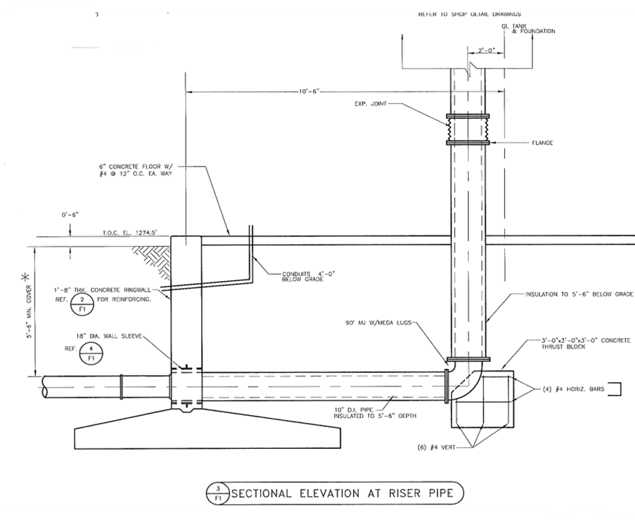
1. Input Data
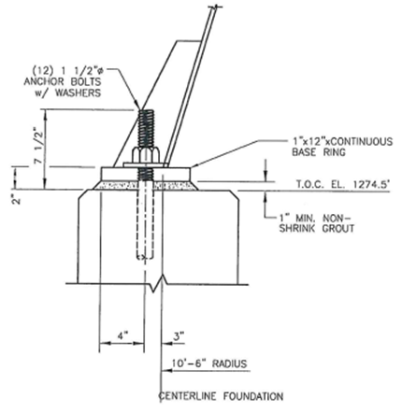
A. Geometry Input
- t_{rw} = ring wall thickness (ft)
- B = footing base width (ft)
- R_{cl} = radius to foundation centerline (ft)
- TCE = top of concrete elevation (ft)
- t_{edge} = footing edge thickness (ft)
- cc = concrete cover to reinforcement (in)
- R_{in} = inner radius
- R_{out} = outer radius
- A = footing plan area
- R_{rw} = ring wall centerline radius

B. Material Input
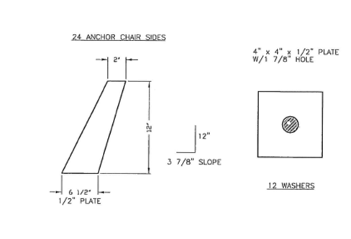
- f'c = concrete compressive strength
- fy = reinforcement yield strength
- γc = concrete unit weight
- λ = lightweight concrete factor, if applicable
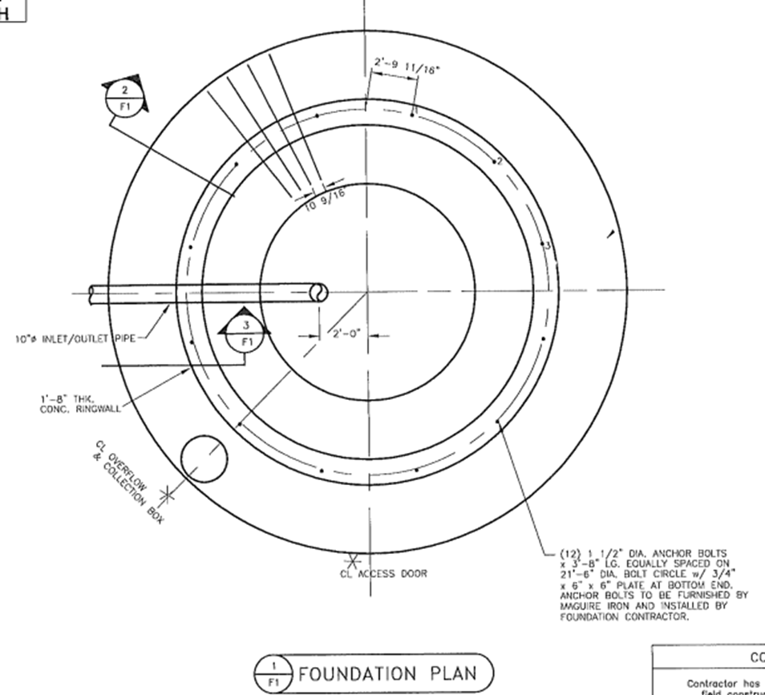
C. Geotechnical Input
- q_{allow} = allowable soil bearing pressure
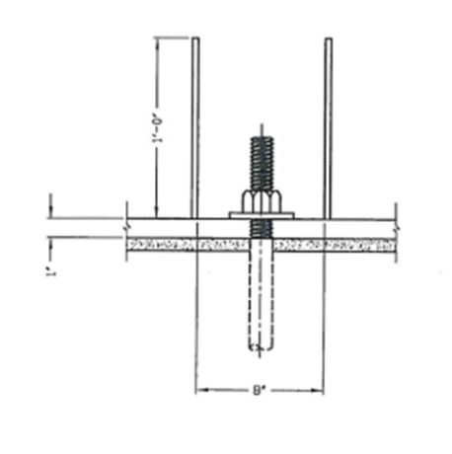
- μ = friction coefficient, if needed

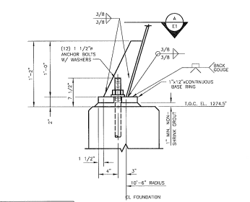
D. Loading Input
- V_{water} = water volume
- γ_{w} = unit weight of water
- W_{tank} = tank dead load
- W_{sup} = superimposed load
- M_{u} = factored flexural moment for footing strip
- V_{u} = one-way shear demand
- V_{up} = punching shear demand
- B_{u} = concrete bearing demand
- A₁ = loaded area for bearing
- A₂ = supporting area for bearing
- b₀ = critical punching perimeter
3.1 Geometry Calculation
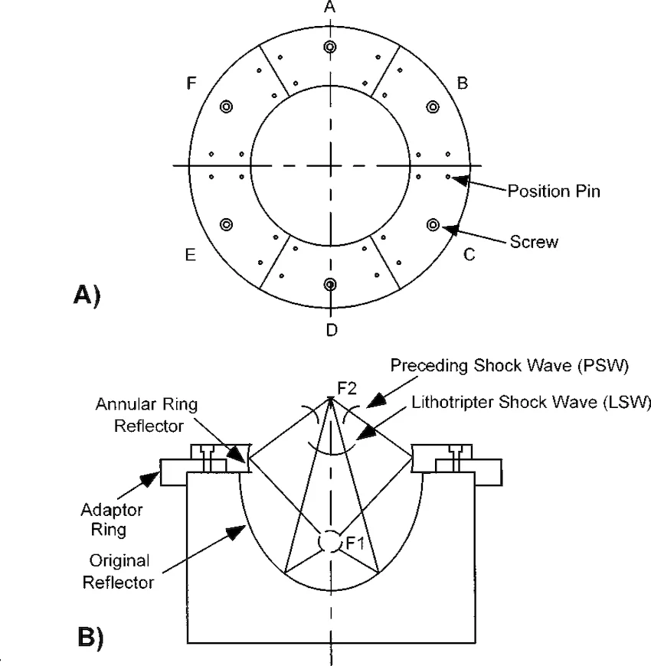
1) Inner radius of footing
$R_{in}=R_{cl}-\frac{B}{2}$
2) Outer radius of footing
$$R_{out}=R_{cl}+\frac{B}{2}$$
3) Footing plan area
$$A=π\left(R_{out}^{2} − R_{in}^{2}\right)$$
4) Ring wall centerline radius
$$R_{rw}=R_{cl}+\frac{t_{rw}}{2}$$3.2 Service Load Calculation
5) Water weight
$$W_{w}=\frac{V_{water}}{7.48052}⋅\frac{γ_{w}}{1000}$$
6) Tank dead load
$$W_{tank}=\text{input value}$$
7) Superimposed load
$$W_{sup}=\text{input value}$$

8) Footing self-weight
$$W_{f}=A⋅t_{edge}⋅\frac{γ_{c}}{1000}$$
9) Total service vertical load
$$V_{s}=W_{w}+W_{tank}+W_{sup}+W_{f}$$
10) Allowable soil bearing pressure
$$q_{allow}=\frac{\text{input allowable soil bearing}}{1000}$$
11) Service bearing pressure
$$q_{s}=\frac{V_{s}}{A}$$
12) Bearing utilization ratio
$$U_{b}=\frac{q_{s}}{q_{allow}}$$
Bearing requirement
$$U_{b}≤1.0$$
3.3 Flexural Design of Ring Footing Strip
This part is based on a 1-foot circumferential strip.
13) Effective depth
$$d=t_{edge}×12-cc$$
14) Strip width
$$b=12\text{ in}$$
15) Concrete strength
$$f_{c}^{'}=\text{input value}$$
16) Steel yield strength
$$f_{y}=\text{input value}$$
17) Lightweight factor
$$λ=\text{input value}$$
18) Beta one factor
$$β_{1}=\left\{\begin{matrix}0.85 & \text{if }f_{c}^{'}≤4000 \\ \max\left(0.65, 0.85-0.05\frac{f_{c}^{'}-4000}{1000}\right) & \text{if }f_{c}^{'}>4000\end{matrix}\right.$$
19) Yield strain
$$ε_{ty}=\frac{f_{y}}{E_{s}}$$
20) Compression block depth
Use the same form implemented in the Excel file:
$$a=\frac{A_{s}f_{y}}{0.85 b}$$
21) Neutral axis depth
$$c=\frac{a}{β_{1}}$$
22) Net tensile strain
$$ε_{t}=0.003\frac{d-c}{c}$$
23) Strength reduction factor
$$ϕ=\left\{\begin{matrix}0.90 & \text{if }ε_{t}≥ε_{ty}+0.003 \\ 0.65 & \text{if }ε_{t}≤ε_{ty} \\ 0.65+0.25\frac{ε_{t}-ε_{ty}}{0.003} & \text{otherwise}\end{matrix}\right.$$
24) Nominal moment capacity
$$M_{n}=A_{s}f_{y}\left(d − \frac{a}{2}\right)$$
25) Design moment strength
$$ϕM_{n}=ϕM_{n}/1000$$
26) Flexural utilization ratio
$$U_{f}=\frac{M_{u}}{ϕM_{n}}$$
Flexural requirement
$$U_{f}≤1.0$$
27) Required nominal moment for steel design
$$M_{n,req}=\frac{M_{u}×1000}{0.9}$$
28) Required steel area
$$A_{s,req}=\frac{f_{y}d-\sqrt{\left(f_{y}d)^{2} − 4\left(\frac{f_{y}^{2}}{2(0.85f_{c}^{'}b)}\right)M_{n,req}\right.}}{2\left(\frac{f_{y}^{2}}{2(0.85f_{c}^{'}b)}\right)}$$
29) Provided steel area
$$A_{s,prov}=\frac{A_{bar}×12}{s_{prov}}$$
30) Required bar spacing
$$s_{req}=\frac{A_{bar}×12}{A_{s,req}}$$
3.4 One-Way Shear Check
31) Effective depth
$$d=\text{from flexure section}$$
32) Strip width
$$b=12\text{ in}$$

33) Total member thickness
$$h=t_{edge}×12$$
34) Size effect factor
$$λ_{s}=min⁡\left(1 , \frac{2}{1+d/10}\right)$$
35) Reinforcement ratio
$$ρ_{w}=\frac{A_{s}}{bd}$$
36) Gross concrete area
$$A_{g}=bh$$
37) Nominal one-way shear strength
Use the exact expression from the Excel logic.
38) Design one-way shear strength
$$ϕV_{n}=ϕV_{n}/1000$$
39) One-way shear utilization ratio
$$U_{v}=\frac{V_{u}}{ϕV_{n}}$$
One-way shear requirement
$$U_{v}≤1.0$$
3.5 Punching Shear Check
40) Critical perimeter
$$b_{0}=\text{input value}$$41) Beta factor
$$β=1$$
42) Column location factor
$$α_{s}=\left\{\begin{matrix}40 & \text{Interior} \\ 30 & \text{Edge} \\ 20 & \text{Corner}\end{matrix}\right.$$43) Punching shear stress limits
Use the three expressions from the Excel logic and take the minimum controlling value:
$$v_{c1}=4λ\sqrt{f_{c}^{'}} \\ v_{c2}=\left(2 + \frac{4}{β}\right)λ\sqrt{f_{c}^{'}} \\ v_{c3}=\left(2 + α_{s}\frac{d}{b_{0}}\right)λ\sqrt{f_{c}^{'}}$$44) Governing punching shear stress
$$v_{c}=min⁡(v_{c1},v_{c2},v_{c3})$$
45) Nominal punching shear strength
$$V_{n,p}=v_{c} b_{0} d$$

46) Design punching shear strength
$$ϕV_{n,p}=ϕV_{n,p}/1000$$

47) Punching shear utilization ratio
$$U_{p}=\frac{V_{up}}{ϕV_{n,p}}$$
Punching requirement
$$U_{p}≤1.0$$
3.6 Concrete Bearing Check
48) Nominal concrete bearing strength
If bearing enhancement is permitted:
$$R_{n}=min⁡\left(0.85f_{c}^{'}A_{1}\sqrt{\frac{A_{2}}{A_{1}}}, 2(0.85f_{c}^{'}A_{1})\right)$$
If enhancement is not permitted:
$$R_{n}=0.85f_{c}^{'}A_{1}$$
49) Design concrete bearing strength
$$ϕR_{n}=ϕR_{n}/1000$$
50) Concrete bearing utilization ratio
$$U_{br}=\frac{B_{u}}{ϕR_{n}}$$Bearing requirement
$$U_{br}≤1.0$$

